Problema 1
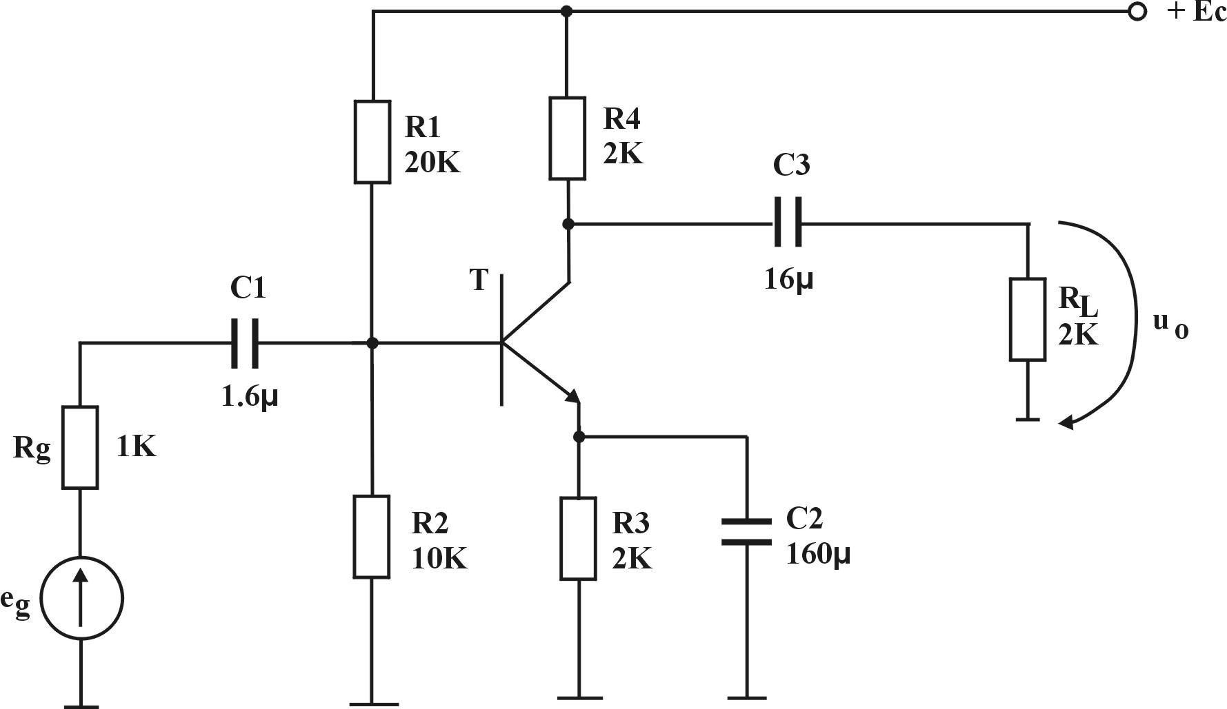
$T:g_{m}=\text{40}\frac{\text{mA}}{V};r_{b'e}=5K;r_{\text{ce}}=∞;r_{\text{bb}'}=0$ Se cere $f_{j}$

Rezolvare
$$f_{j}=f_{p_{1}}+f_{p_{2}}+f_{p_{3}}$$
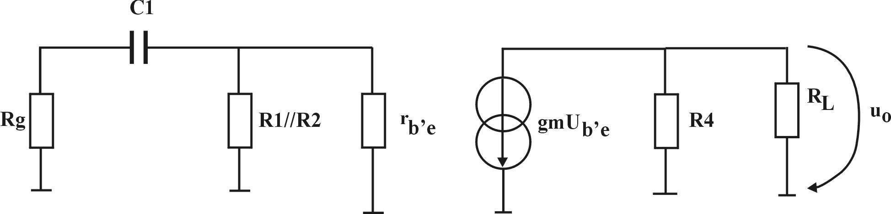
- Cazul C₁

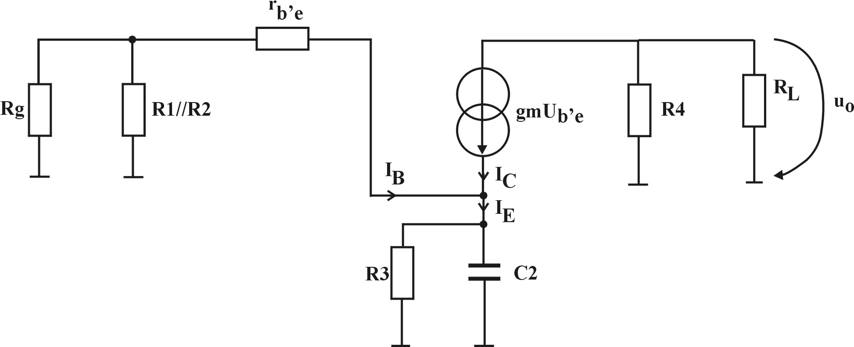
$$f_{p_{1}}=\frac{1}{2{πC}_{1}\left(R_{g}+R_{1}‖R_{2}‖r_{b'e}\right)}=\text{33}\text{.}3\text{Hz}$$
b.)
$$R_{S_{2}}=R_{3}‖R_{3}$$
$$\begin{aligned}R_{e}=\left|\frac{U}{I}\right|=\frac{U_{R_{e}}}{I_{E}}=\frac{U_{R_{e}}}{I_{B}+I_{C}}=\frac{U_{R_{e}}}{I_{B}\left(β+1\right)}=\frac{I_{B}\left(R_{g}‖R_{1}‖R_{2}+r_{b'e}\right)}{I_{B}\left(β+1\right)}⇒ \\ \end{aligned}$$
$$⇒R_{S_{2}}=R_{3}‖R_{e}=\text{30}Ω⇒f_{p_{2}}=\frac{1}{2{πC}_{2}R_{S_{2}}}=\text{33}\text{.}3\text{Hz}$$
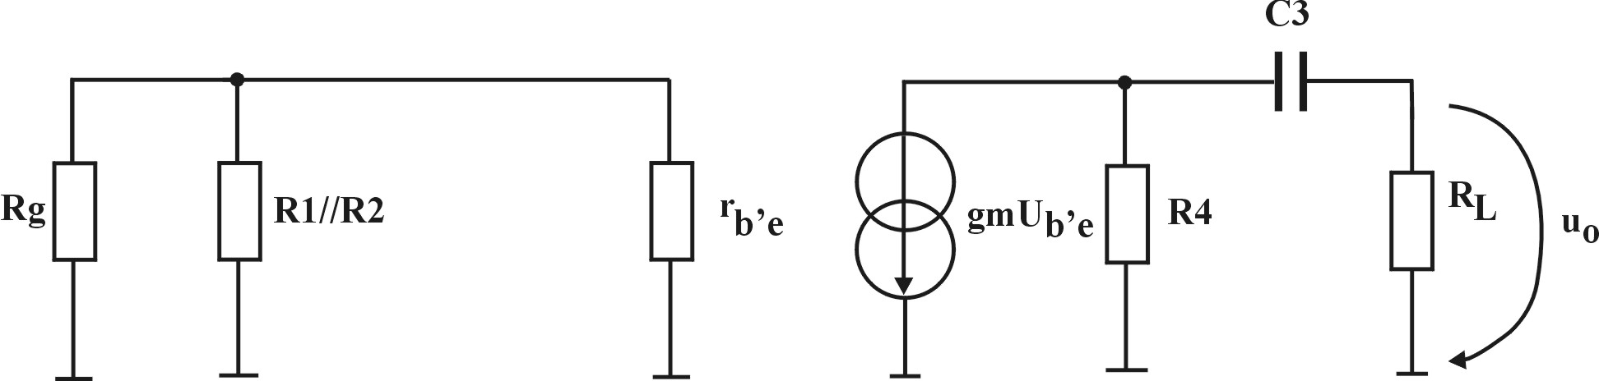
$R_{S_{3}}=R_{4}+R_{L}⇒$
$$f_{p_{3}}=\frac{1}{2{πC}_{3}R_{S_{3}}}=2\text{.}5\text{Hz}⇒$$
$$⇒f_{j}=\text{66}\text{.}6+2\text{.}5=\text{69}\text{.}1\text{Hz}$$
Problema 2
Pentru circuitul din figură se cunosc parametrii amplificatorului
$A_{u}={\text{10}}^{2};R_{i}=1MΩ;R_{o}=1KΩ$.
- Folosind metoda constantelor de gol să se calculeze $υ$ limită superioară
- Aplicând teorema lui Miller să se calculeze $f_{î}$

Rezolvare
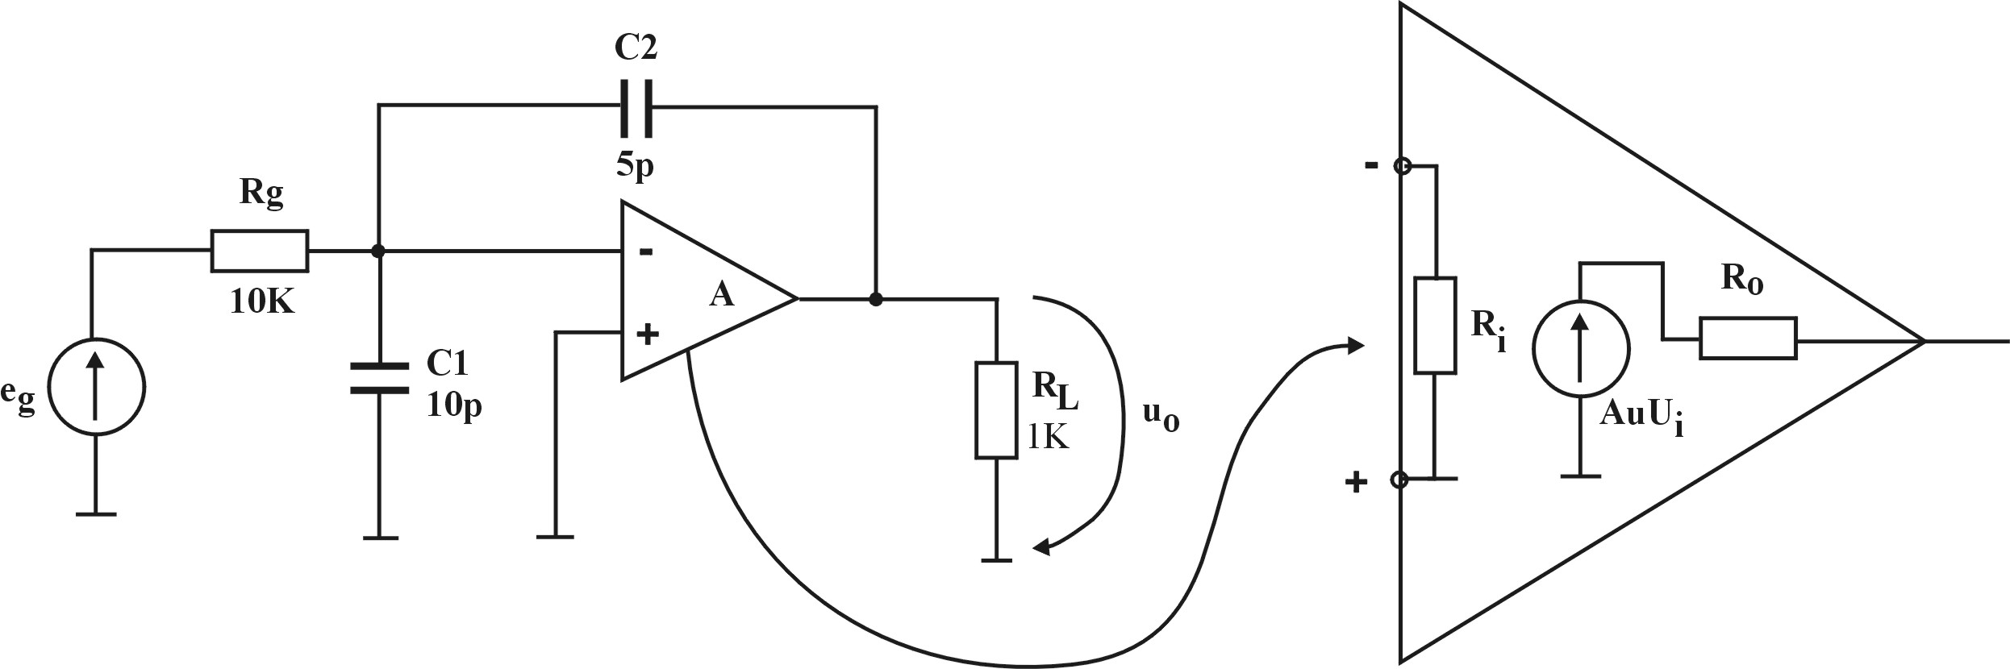
a.)
$\begin{aligned}C_{1}→f_{p_{1}}=\frac{1}{2{πC}_{1}R_{p_{1}}} \\ C_{2}→f_{p_{2}}=\frac{1}{2{πC}_{2}R_{p_{2}}}\end{aligned}$ $⇒f_{î}=\frac{1}{\frac{1}{f_{p_{1}}}+\frac{1}{f_{p_{2}}}}$
$$R_{p_{1}}=R_{g}‖R_{L}⇒f_{p_{1}}=1\text{.}6\text{MHz}$$
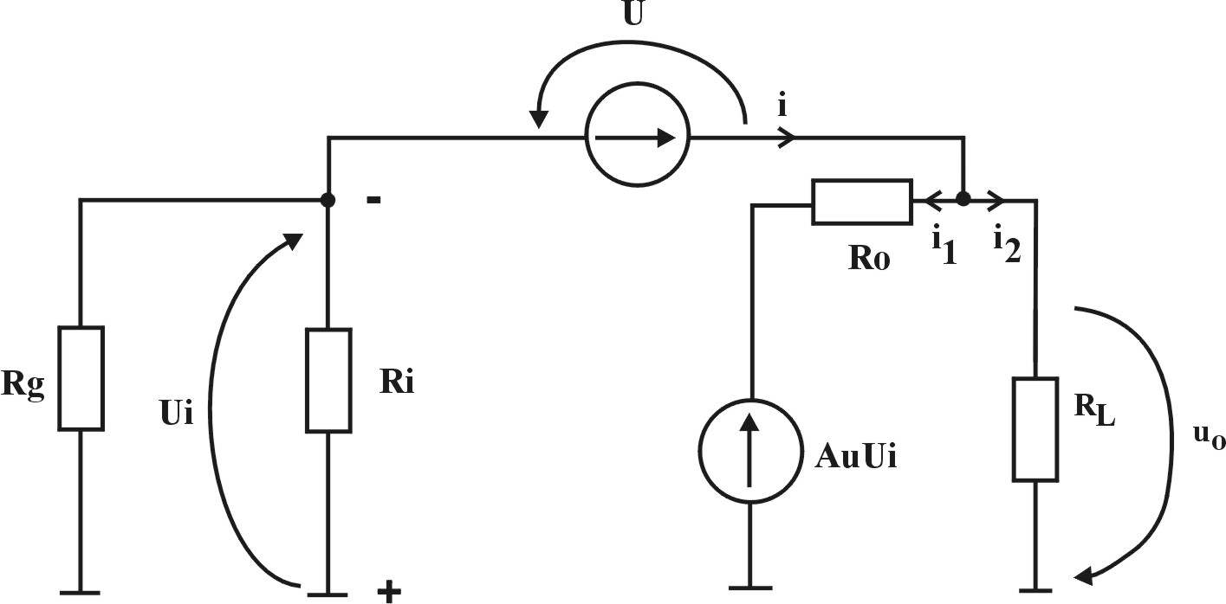
$$i=i_{1}+i_{2}⇒\frac{U_{i}}{R_{g}‖R_{i}}=\frac{U−U_{i}−A_{u}U_{i}}{R_{o}}+\frac{U−U_{i}}{R_{L}}$$
$$R_{p_{2}}=R_{o}‖R_{L}+R_{g}‖R_{i}\left(1+A_{u}\frac{R_{L}}{R_{L}+R_{o}}\right)$$
$$f_{p_{2}}=\text{62}\text{KHz}⇒f_{î}=\text{62}\text{KHz}$$
- $$f_{p_{1}}=\frac{1}{2π\left(C_{\text{10}}+C_{1}\right)R_{g}‖R_{i}}=\text{60}\text{.}4\text{KHz}$$
$$f_{p_{2}}=\frac{1}{2π\left(C_{\text{20}}\right)R_{g}‖R_{i}}=\text{64}\text{KHz}$$
$\begin{aligned}C_{\text{10}}=C_{2}\left(1−k\right) \\ C_{\text{20}}=C_{2}(1−\frac{1}{k}) \\ k=\frac{U_{o}}{U_{i}}=\frac{A_{u}U_{i}\frac{R_{L}}{R_{o}+R_{L}}}{U_{i}}\end{aligned}$

