Reacţia paralel – serie

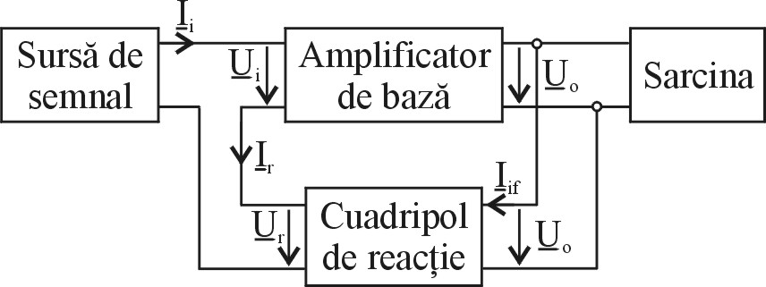
Se utilizează aceeaşi metodologie de studiu.

La fel ca şi în cazul precedent, se echivalează amplificatorul de bază şi circuitul de reacţie prin scheme cuadripolae potrivite.
Sch,sch,schsch
$\begin{aligned}\text{VI}:{\underline{U}}_{1},{\underline{I}}_{2} \\ \text{VD}:{\underline{I}}_{1},{\underline{U}}_{2} \\ {\underline{I}}_{1}={\underline{F}}_{\text{11}}{\underline{U}}_{1}+{\underline{F}}_{\text{12}}{\underline{I}}_{2} \\ {\underline{U}}_{1}={\underline{F}}_{\text{21}}{\underline{U}}_{1}+{\underline{F}}_{\text{22}}{\underline{I}}_{2}(1)\end{aligned}$
$\begin{aligned}R_{\text{if}}=\frac{{\underline{U}}_{O}}{{\underline{I}}_{\text{if}}}|_{{\underline{I}}_{2}=0} \\ \underline{β}=\frac{{\underline{U}}_{R}}{{\underline{U}}_{O}}|_{{\underline{I}}_{r}=0} \\ R_{\text{of}}=\frac{{\underline{U}}_{r}}{{\underline{I}}_{r}}|_{{\underline{U}}_{O}=0} \\ {\underline{A}}_{u}⋅{\underline{U}}_{i}=\underline{A}'_{u}⋅\underline{U}'_{i}\end{aligned}$
În etapa următoare se rearanjează elementele din schemă.
Sch
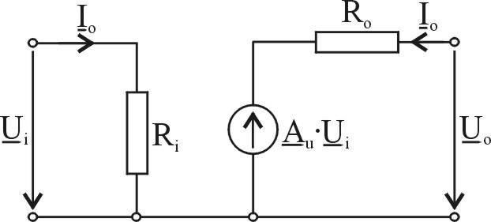
$\begin{aligned}R_{i}=R_{g}+R'_{i}+R_{\text{of}} \\ R_{o}=R_{o} \\ {\underline{A}}_{u}=\frac{{\underline{U}}_{o}}{{\underline{U}}_{i}}={\underline{A}}_{u}⋅{\underline{U}}_{i}⋅\frac{R_{L}}{R_{o}+R_{L}}⋅\frac{1}{{\underline{U}}_{i}}={\underline{A}}_{u}⋅\frac{R_{L}}{R_{o}+R_{L}}\end{aligned}$
Ultima etapa prevede calculul parametrilor amplificatorului cu reacţie.

$\begin{aligned}{\underline{E}}_{g}={\underline{U}}_{i}+\underline{β}⋅{\underline{U}}_{o} \\ {\underline{A}}_{\text{ur}}=\frac{{\underline{U}}_{o}}{{\underline{E}}_{g}}=\frac{{\underline{U}}_{o}}{{\underline{U}}_{i}+\underline{β}⋅{\underline{U}}_{o}}=\frac{{\underline{A}}_{u}}{1+\underline{β}⋅{\underline{A}}_{u}} \\ R_{\text{ir}}=\frac{{\underline{E}}_{g}}{{\underline{I}}_{i}}=\frac{{\underline{U}}_{i}+\underline{β}⋅{\underline{U}}_{o}}{\frac{{\underline{U}}_{i}}{{\underline{R}}_{i}}}=R_{i}\left(1+\underline{β}⋅{\underline{A}}_{u}\right) \\ R_{\text{or}}=−\frac{{\underline{U}}_{o}}{{\underline{I}}_{o}}|_{{\underline{E}}_{g}=0} \\ {\underline{U}}_{i}+\underline{β}⋅{\underline{U}}_{o}=0→{\underline{U}}_{i}=−\underline{β}⋅{\underline{U}}_{o} \\ {\underline{I}}_{o}=\frac{{\underline{A}}_{u}{\underline{U}}_{i}−{\underline{U}}_{o}}{{\underline{R}}_{o}}=−\frac{{\underline{U}}_{o}+{\underline{A}}_{u}\underline{β}⋅{\underline{U}}_{o}}{{\underline{R}}_{o}} \\ R_{\text{or}}=\frac{R_{o}}{1+\underline{β}⋅{\underline{A}}_{u}} \\ {\underline{A}}_{u}=\underset{R_{L}→∞}{\text{lim}}{\underline{A}}_{u}\end{aligned}$

Reacţie serie – paralel

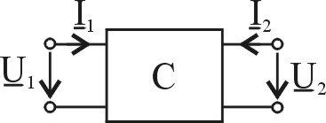
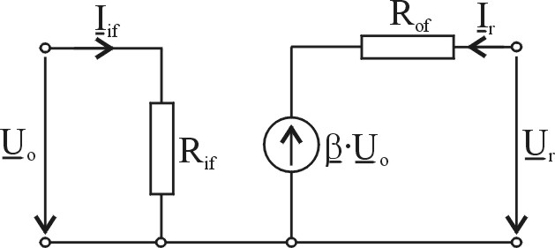
Sch,sch,sch,sch,sch
$\begin{aligned}\text{VI}:{\underline{I}}_{1},{\underline{U}}_{2} \\ \text{VD}:{\underline{U}}_{1},{\underline{I}}_{2} \\ {\underline{U}}_{1}={\underline{H}}_{\text{11}}{\underline{I}}_{1}+{\underline{H}}_{\text{12}}{\underline{U}}_{2} \\ {\underline{I}}_{2}={\underline{H}}_{\text{21}}{\underline{I}}_{1}+{\underline{H}}_{\text{22}}{\underline{U}}_{2}(1)\end{aligned}$
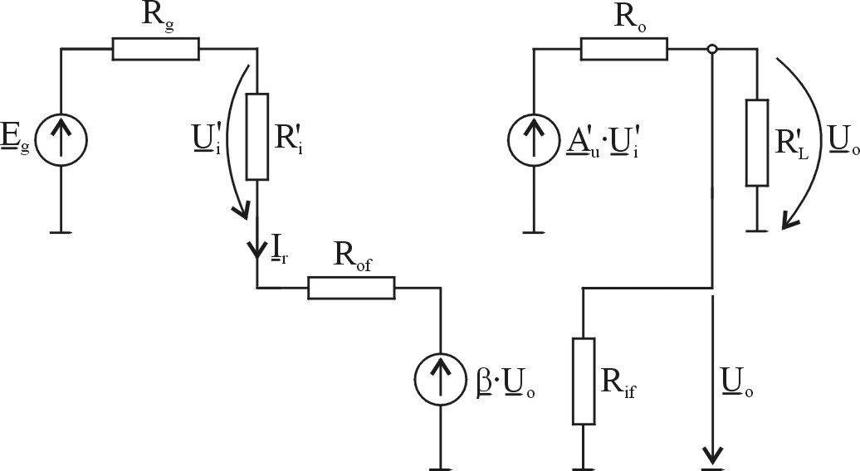
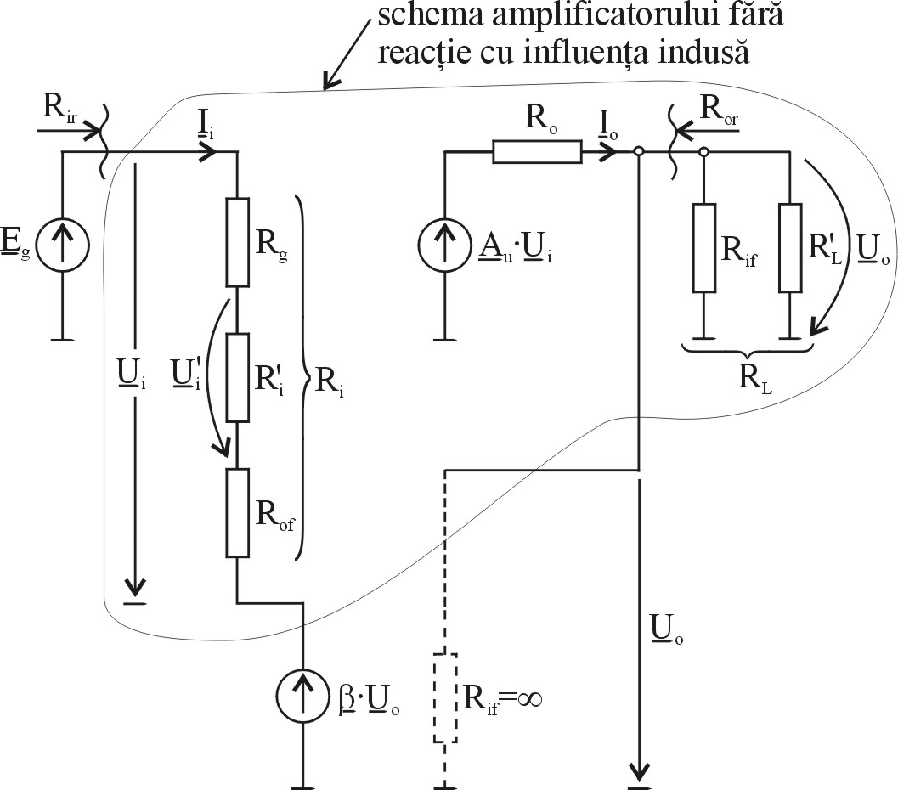
$\begin{aligned}R_{\text{if}}=\frac{{\underline{U}}_{\text{if}}}{{\underline{I}}_{\text{if}}}|_{{\underline{U}}_{r}=0} \\ \underline{β}=\frac{{\underline{I}}_{R}}{{\underline{I}}_{\text{if}}}|_{{\underline{U}}_{r}=0} \\ R_{\text{of}}=\frac{{\underline{U}}_{r}}{{\underline{I}}_{r}}|_{{\underline{I}}_{\text{if}}=0}\end{aligned}$
Se rearanjează schema.
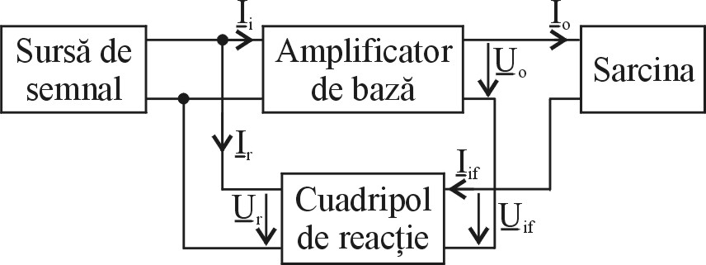
$\begin{aligned}R_{i}=R_{g}‖R_{\text{of}}‖R'_{i} \\ R_{o} \\ {\underline{A}}_{I}=\frac{{\underline{I}}_{o}}{{\underline{I}}_{i}}={\underline{A}}_{I}⋅{\underline{I}}_{i}⋅\frac{R_{o}}{R_{o}+R_{L}}⋅\frac{1}{{\underline{I}}_{i}}\end{aligned}$

Se calculează parametrii amplificatorului cu reacţie.
$\begin{aligned}{\underline{I}}_{g}={\underline{I}}_{i}+\underline{β}⋅{\underline{I}}_{\text{if}} \\ {\underline{A}}_{\text{ir}}=\frac{{\underline{I}}_{o}}{{\underline{I}}_{g}}=\frac{{\underline{I}}_{o}}{{\underline{I}}_{i}+\underline{β}⋅{\underline{I}}_{\text{if}}}=\frac{{\underline{A}}_{I}}{1+\underline{β}⋅{\underline{A}}_{I}} \\ R_{\text{ir}}=\frac{{\underline{U}}_{i}}{{\underline{I}}_{g}}=\frac{{\underline{U}}_{i}}{{\underline{I}}_{i}+\underline{β}⋅{\underline{I}}_{o}}=\frac{R_{i}}{1+\underline{β}⋅{\underline{A}}_{I}} \\ R_{\text{or}}=−\frac{{\underline{U}}_{o}}{{\underline{I}}_{o}}|_{{\underline{I}}_{g}=0} \\ {\underline{I}}_{g}=0→{\underline{I}}_{i}=−\underline{β}⋅{\underline{I}}_{o} \\ R_{\text{or}}=−\frac{R_{o}\left({\underline{A}}_{i}{\underline{I}}_{i}−{\underline{I}}_{o}\right)}{{\underline{I}}_{o}}=|_{{\underline{I}}_{g}=o}=\frac{R_{o}{\underline{I}}_{o}\left(1+\underline{β}⋅{\underline{A}}_{i}\right)}{{\underline{I}}_{o}}=R_{o}\left(1+\underline{β}⋅{\underline{A}}_{i}\right)\end{aligned}$
Obs
- din cele prezentate până aici s-a putu constata că pentru determinarea elementelor componente ale cuadripolului de reacţie trebuie scurtcircuitate nodurile, respectiv întrerupe buclele.
- se constată apoi că reacţia de tip serie măreşte rezistenţa (de intrare respectiv ieşire)

Reacţia serie – serie

Sch.sch.sch.schsch
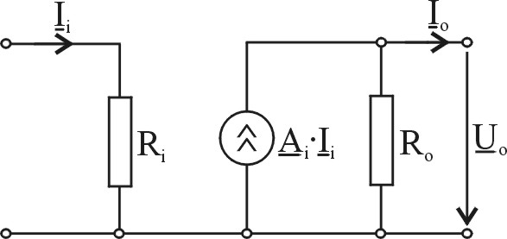
$\begin{aligned}\text{VI}:{\underline{I}}_{1},{\underline{I}}_{2} \\ \text{VD}:{\underline{U}}_{1},{\underline{I}}_{2} \\ {\underline{U}}_{1}={\underline{Z}}_{\text{11}}{\underline{I}}_{1}+{\underline{Z}}_{\text{12}}{\underline{I}}_{2} \\ {\underline{U}}_{2}={\underline{Z}}_{\text{21}}{\underline{I}}_{1}+{\underline{Z}}_{\text{22}}{\underline{I}}_{2}(1)\end{aligned}$
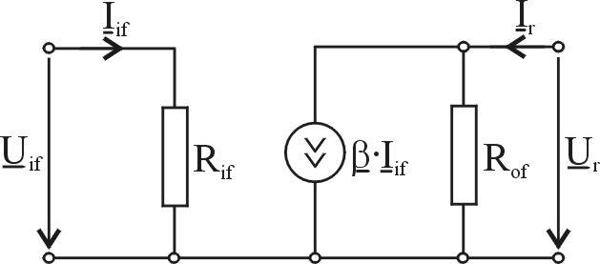
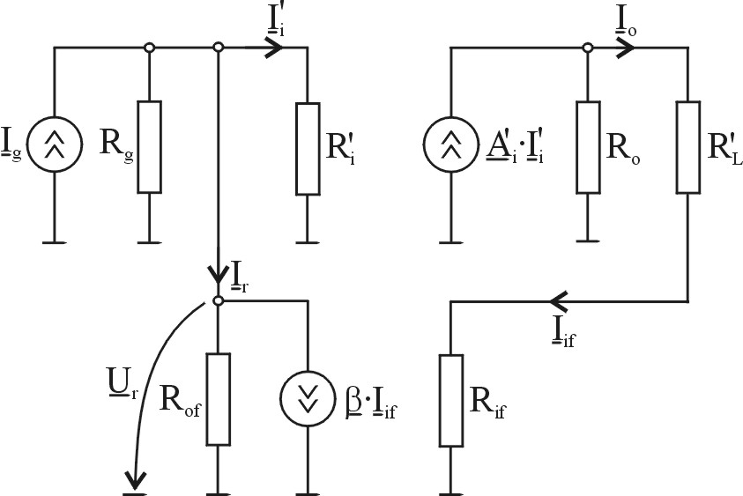
$\begin{aligned}R_{\text{if}}=\frac{{\underline{U}}_{\text{if}}}{{\underline{I}}_{O}}|_{{\underline{I}}_{r}=0} \\ \underline{β}=\frac{{\underline{U}}_{R}}{{\underline{I}}_{O}}|_{{\underline{I}}_{r}=0} \\ R_{\text{of}}=\frac{{\underline{U}}_{r}}{{\underline{I}}_{r}}|_{{\underline{I}}_{O}=0}\end{aligned}$
${\underline{Y}}_{t}⋅{\underline{U}}_{i}=\underline{Y}'_{t}⋅\underline{U}'$
În continuare se rearanjează schema.
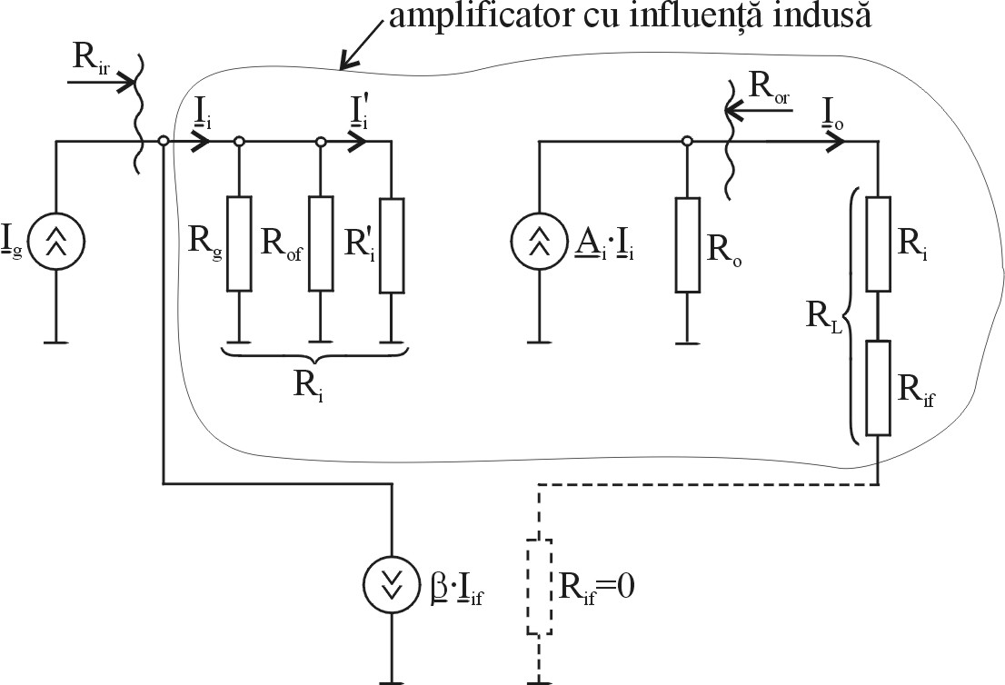
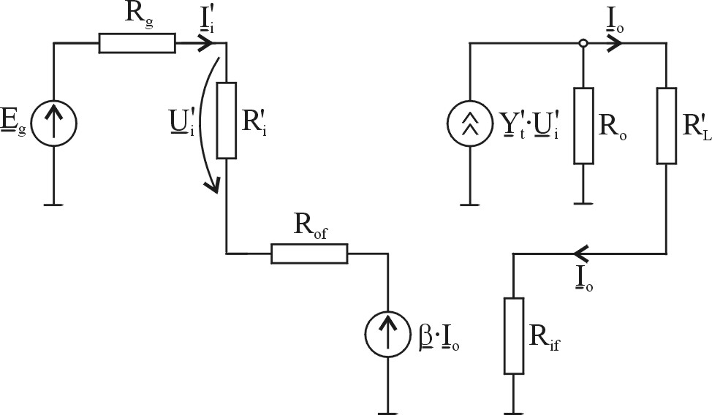
$\begin{aligned}R_{i}=R_{g}+R_{\text{of}}+R'_{i} \\ R_{o}=R_{o} \\ {\underline{Y}}_{T}=\frac{{\underline{I}}_{o}}{{\underline{U}}_{i}}={\underline{Y}}_{I}⋅{\underline{U}}_{i}⋅\frac{R_{o}}{R_{o}+R_{L}}⋅\frac{1}{{\underline{U}}_{i}}\end{aligned}$

Calculul parametrilor amplificatorului cu reacţie:
$$\begin{aligned}{\underline{Y}}_{\text{tr}}=\frac{{\underline{I}}_{o}}{{\underline{E}}_{g}}=\frac{{\underline{I}}_{o}}{{\underline{U}}_{i}+\underline{β}⋅{\underline{I}}_{o}}=\frac{{\underline{Y}}_{T}}{1+\underline{β}⋅{\underline{Y}}_{T}} \\ {\underline{E}}_{g}={\underline{U}}_{i}+\underline{β}⋅{\underline{I}}_{o} \\ R_{\text{ir}}=\frac{{\underline{E}}_{g}}{{\underline{I}}_{i}}=\frac{{\underline{I}}_{i}+\underline{β}⋅{\underline{I}}_{o}}{{\underline{I}}_{i}}=R_{i}+\underset{{\underline{Y}}_{T}}{\underbrace{\underset{R_{i}}{\underbrace{β⋅\frac{{\underline{U}}_{i}}{{\underline{I}}_{i}}}}⋅\frac{{\underline{U}}_{o}}{{\underline{U}}_{i}}}}=R_{i}\left(1+\underline{β}⋅{\underline{Y}}_{T}\right) \\ R_{\text{or}}=−\frac{{\underline{U}}_{o}}{{\underline{I}}_{o}}|{}_{{\underline{I}}_{g}=0} \\ {\underline{I}}_{g}=0→{\underline{I}}_{i}=−\underline{β}⋅{\underline{I}}_{o} \\ R_{\text{or}}=−\frac{R_{o}\left({\underline{A}}_{i}{\underline{I}}_{i}−{\underline{I}}_{o}\right)}{{\underline{I}}_{o}}=|_{{\underline{I}}_{g}=o}=\frac{R_{o}{\underline{I}}_{o}\left(1+\underline{β}⋅{\underline{A}}_{i}\right)}{{\underline{I}}_{o}}=R_{o}\left(1+\underline{β}⋅{\underline{A}}_{i}\right)\end{aligned}$$
